Storage & Cooling Basics — In-Depth, Practical Explanation

🧠 What Is Storage?

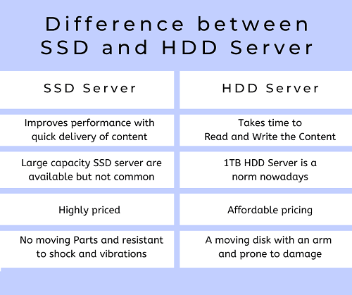
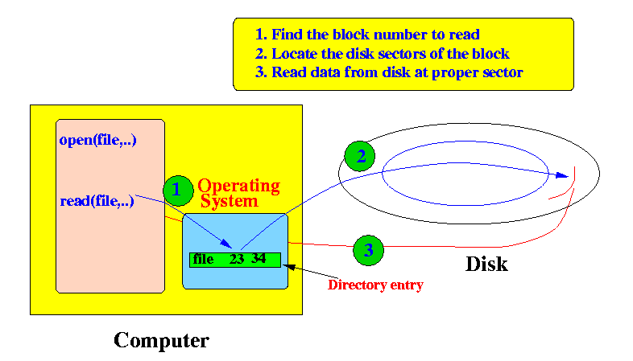
Storage = Long-term memory
Storage permanently holds:
- Operating System (Windows / Linux)
- Applications & software
- Documents, photos, videos
- Datasets, models, project files
📌 Unlike RAM, storage does not clear when power is off.

⚡ Why Storage Speed Matters
Storage speed affects:
- Boot time
- App launch time
- File copy speed
- Game load time
- Dataset loading (AI / simulations)
Fast CPU + slow storage = still feels slow

🧩 Storage Types Explained

1️⃣ HDD (Hard Disk Drive)
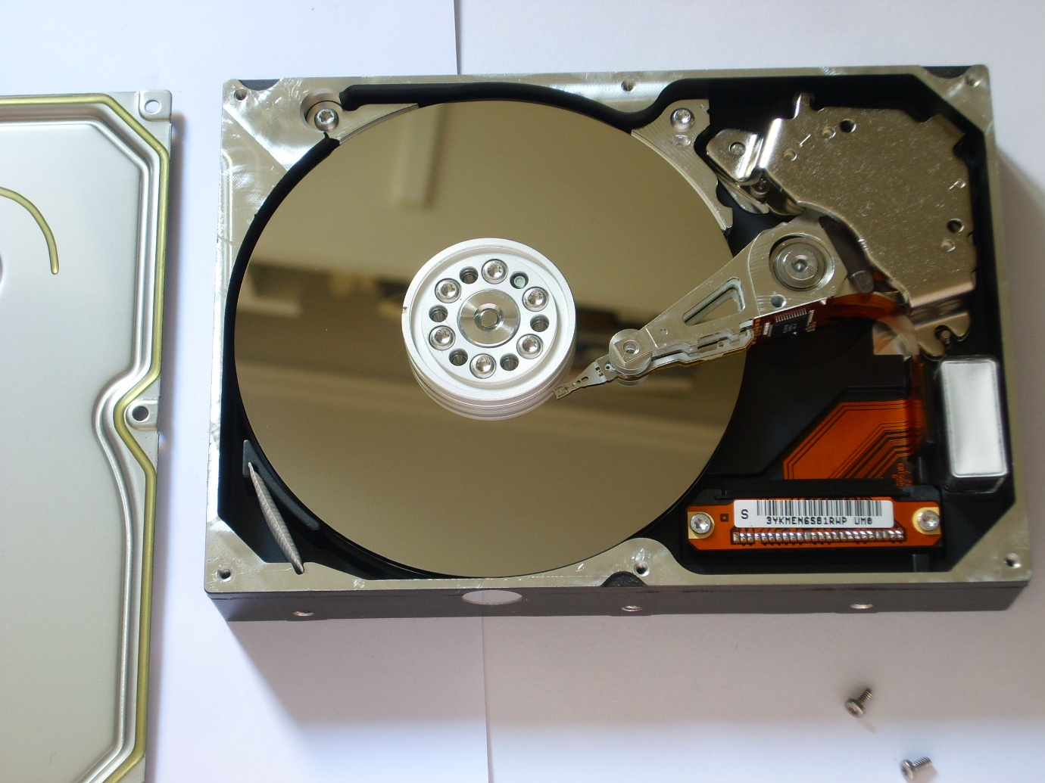
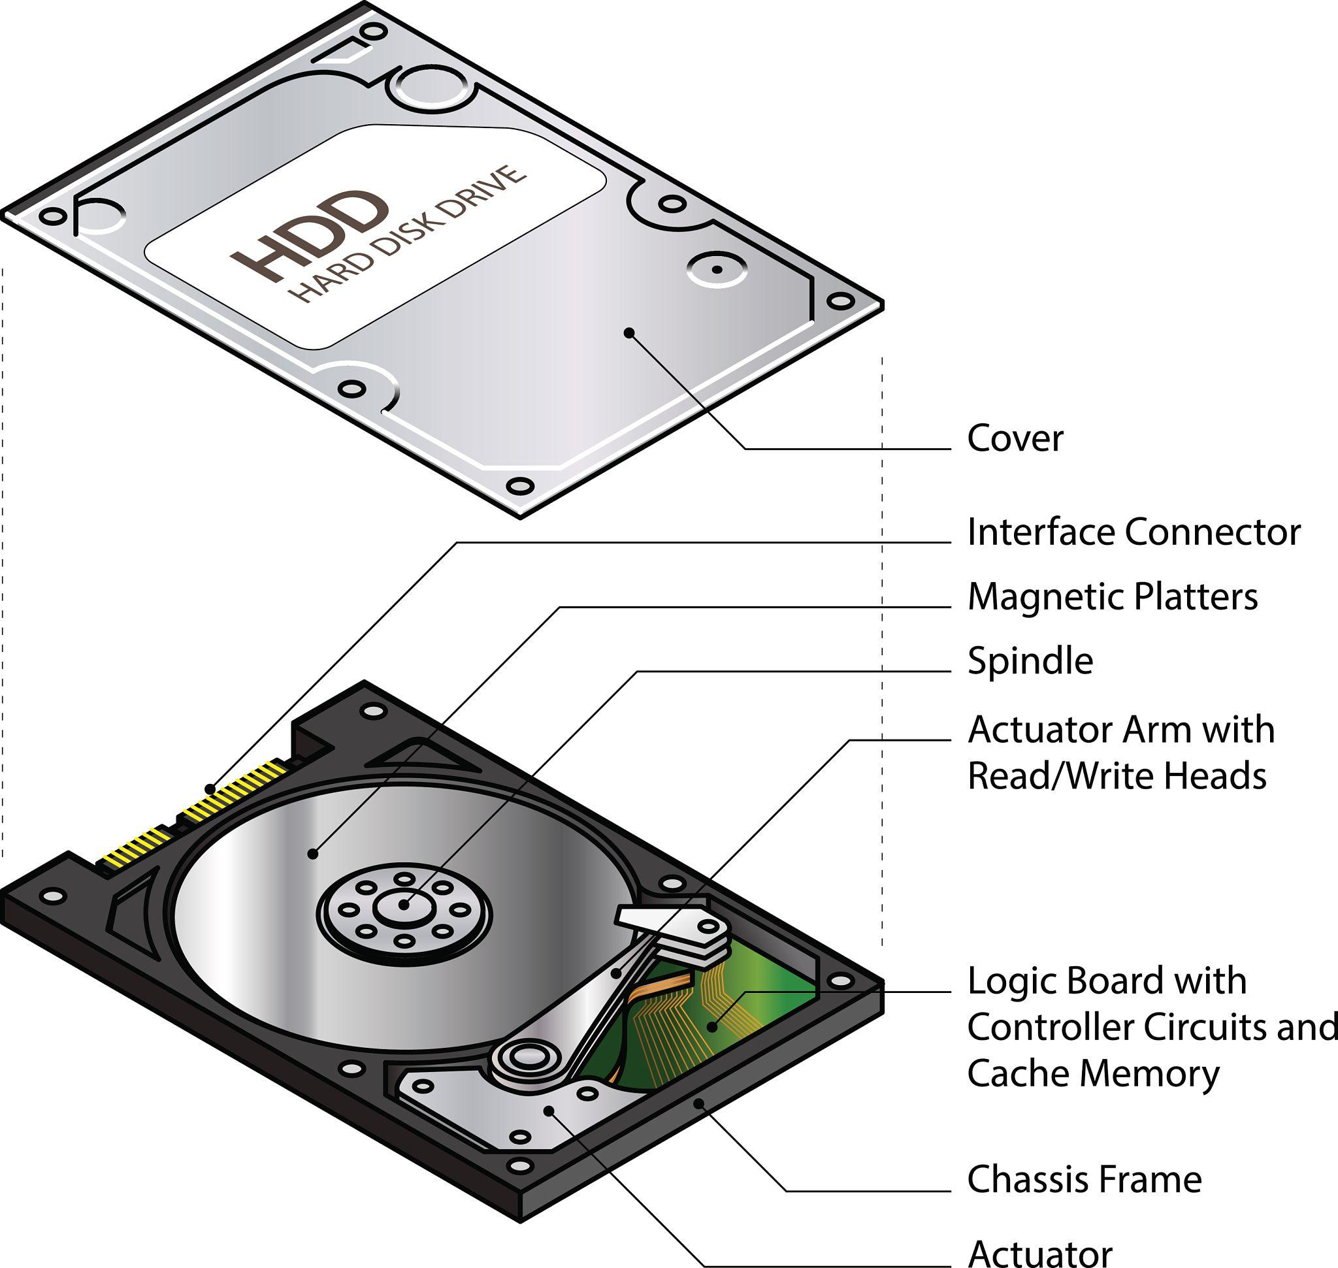
How it works
- Spinning magnetic platters
- Moving read/write head
- Mechanical parts → slow
Characteristics
- ❌ Slow
- ❌ Noisy
- ❌ Fragile (shock sensitive)
- ✅ Very cheap
- ✅ Huge capacity
Typical Speed
- 80–150 MB/s
Best for
- File storage
- Backups
- Media archives

2️⃣ SATA SSD (Solid State Drive)
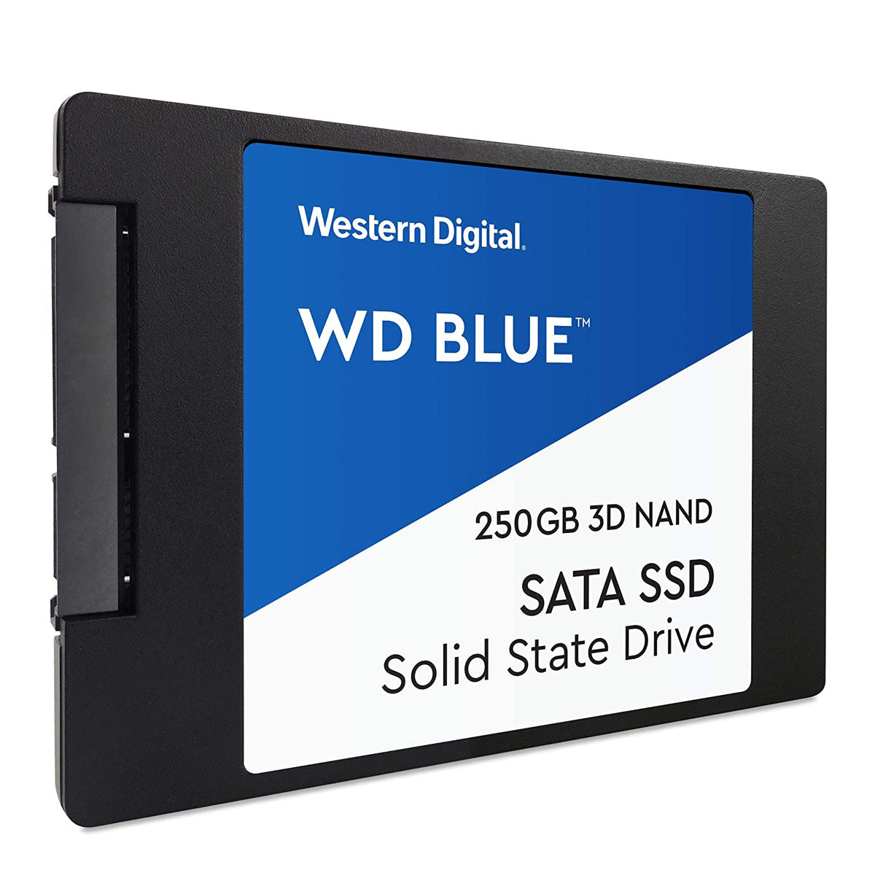
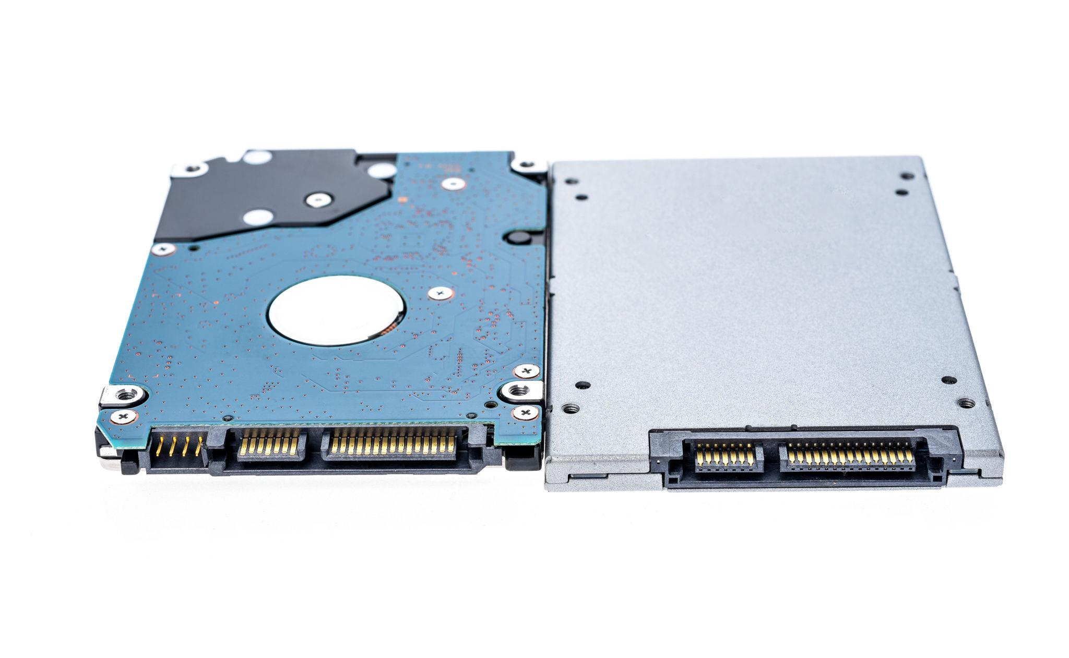
How it works
- NAND flash memory
- No moving parts
Characteristics
- ✅ Fast
- ✅ Silent
- ✅ Durable
- ⚠️ Limited by SATA interface
Typical Speed
- 500–550 MB/s
Best for
- OS drive
- Daily applications
- Budget upgrades

3️⃣ NVMe SSD (M.2 PCIe)
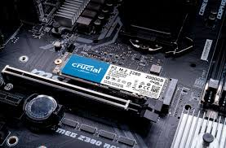
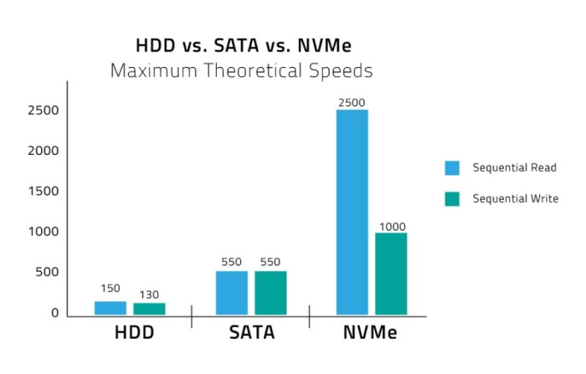
How it works
- Directly connects to CPU via PCIe lanes
- Parallel data paths
Characteristics
- 🚀 Extremely fast
- 🚀 Very low latency
- ⚠️ Can get hot
- ⚠️ More expensive
Typical Speed
- PCIe 3.0 → ~3,500 MB/s
- PCIe 4.0 → ~7,000 MB/s
- PCIe 5.0 → 10,000+ MB/s
Best for
- Fast boot
- Heavy software
- AI datasets
- Video editing
- Simulations

📊 Storage Speed Comparison (Real-World Feel)
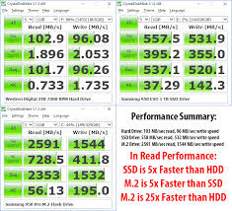
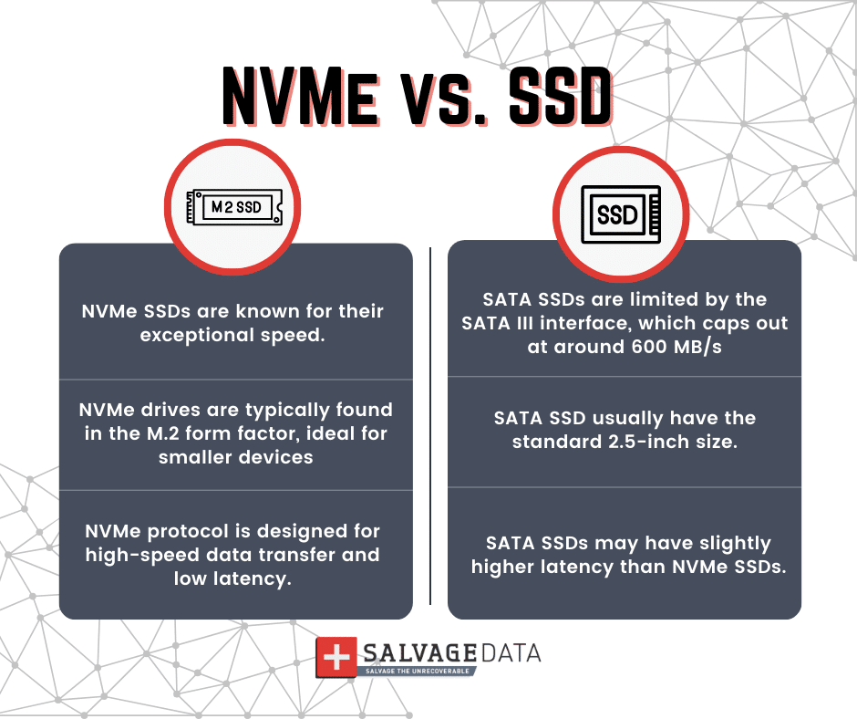
Task | HDD | SATA SSD | NVMe SSD
Windows boot | 60–90s | 15–20s | 5–10s
App open | Slow | Fast | Instant
File copy | Very slow | Fast | Very fast
AI dataset load | Painful | Okay | Smooth
📌 Biggest jump: HDD → SSD
📌 Smaller jump: SATA SSD → NVMe (but still important for heavy work)

⚠️ Important Storage Concepts You Must Know

1️⃣ IOPS (Not Just MB/s)
- Small file access depends on IOPS
- NVMe has huge IOPS advantage
- OS & apps benefit more from IOPS than raw speed

2️⃣ Storage Does NOT Increase FPS
- Faster storage reduces load times
- Once data is loaded → GPU & CPU decide FPS

3️⃣ Separate OS & Data Drives (Best Practice)
- Drive 1: NVMe SSD → OS + software
- Drive 2: SSD/HDD → data & projects
Benefits:
- Faster system
- Safer data
- Easier OS reinstall

4️⃣ SSD Lifespan (TBW)
- SSDs have write limits
- Modern SSDs last many years
- Normal users rarely hit limits

❄️ Cooling & Thermals (Why Heat Matters)
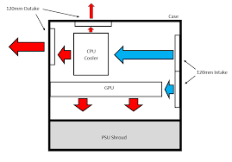
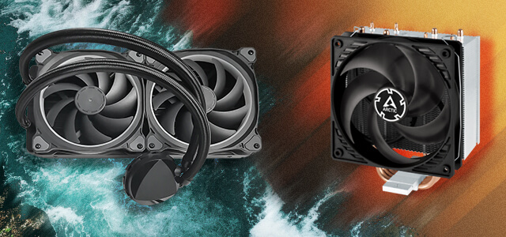
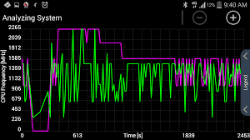
Heat = Enemy of Performance
All components produce heat:
- CPU
- GPU
- SSD (NVMe especially)
- VRMs
Too much heat → Thermal Throttling

🔻 What Is Thermal Throttling?
- Component reaches temperature limit
- Automatically reduces speed
- Prevents damage
- Causes performance drop
📌 Silent performance killer.

🧊 Cooling Types Explained

1️⃣ Air Cooling
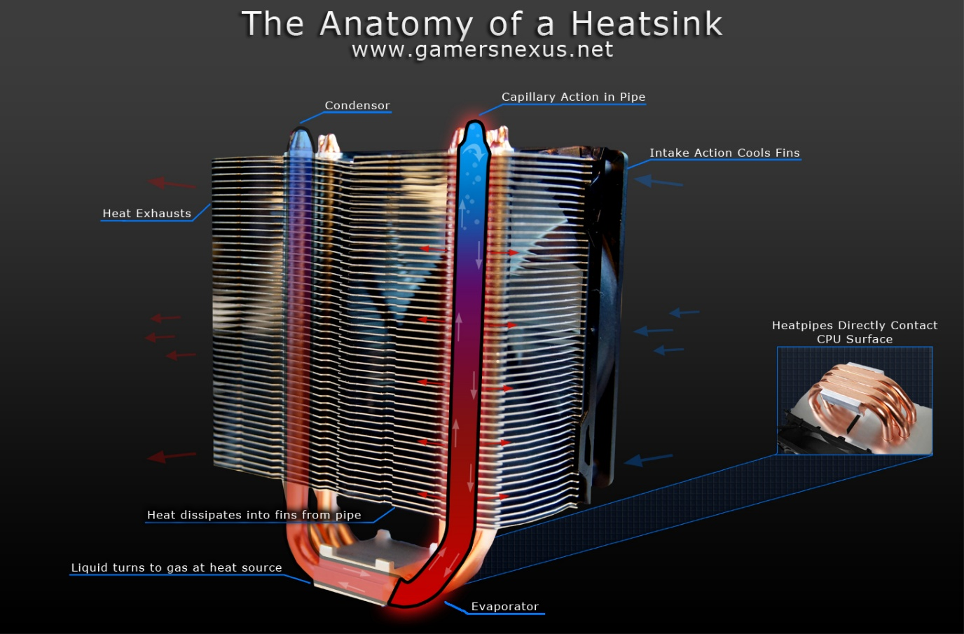
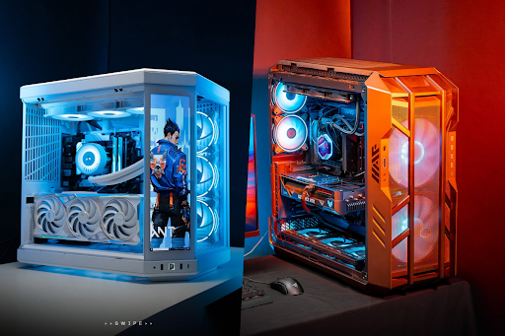
How it works
- Heatsink + fan
- Heat pipes move heat away
Pros
- Reliable
- Cheaper
- Long lifespan
- Easy maintenance
Cons
- Large coolers may block RAM
- Limited for extreme CPUs
Best for
- Students
- Developers
- Most PCs

2️⃣ Liquid Cooling (AIO)
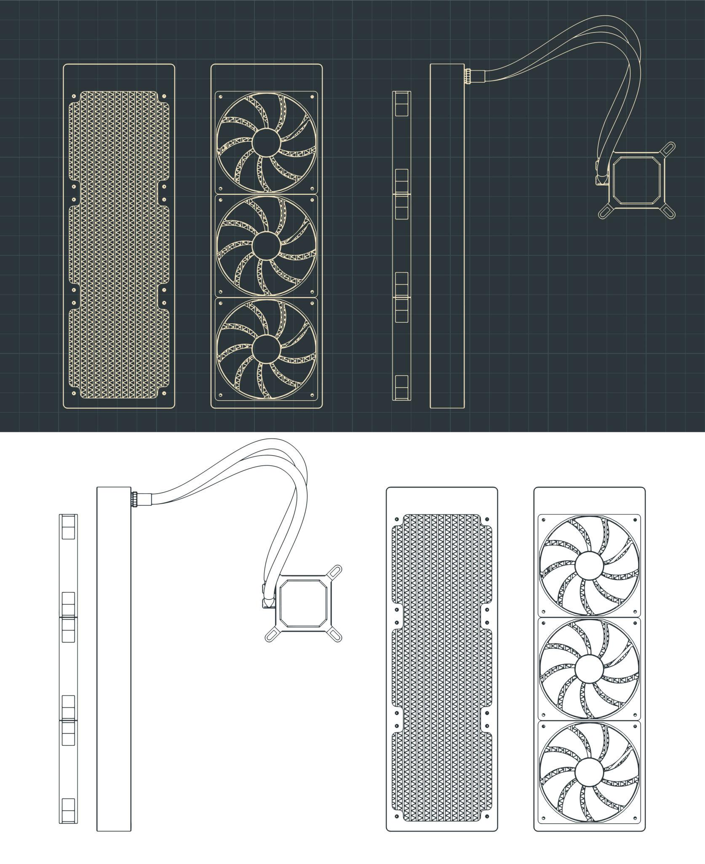
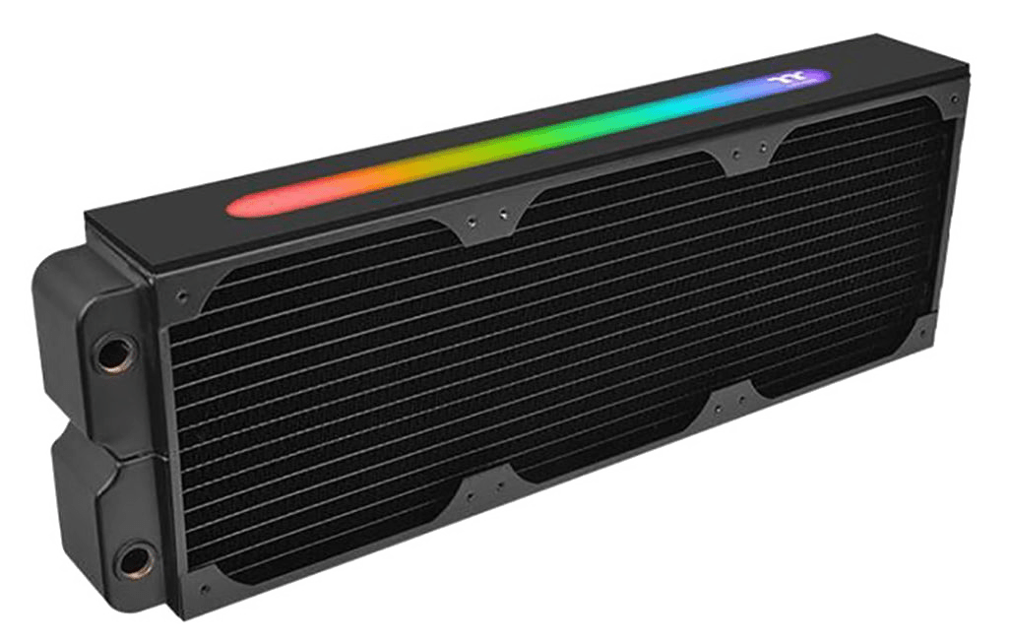
How it works
- Pump moves liquid
- Radiator dissipates heat
Pros
- Better heat dissipation
- Cleaner look
- Handles high-end CPUs
Cons
- Expensive
- Pump failure risk
- Slight maintenance concern
Best for
- High-performance CPUs
- Heavy workloads
- Overclocking

🌬️ Case Airflow (Often Ignored)

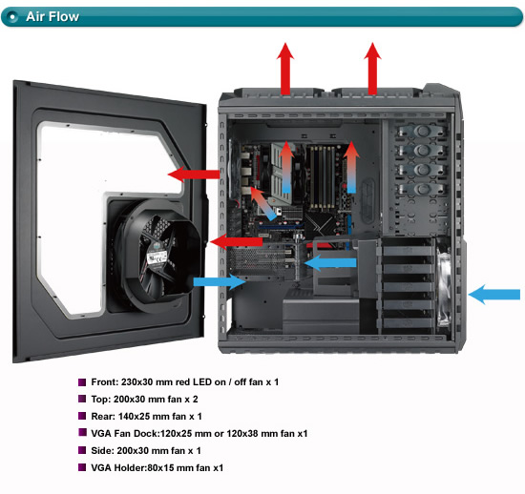
Good airflow:
- Front intake fans
- Rear/top exhaust fans
- Clean cable management
Bad airflow:
- Hot air trapped
- SSD & VRM overheating
- Throttling even with good cooler

🔥 Storage & Heat (NVMe Reality)
- NVMe SSDs can reach 70–80°C
- High temp → speed drop
- Motherboard heatsink helps a lot
📌 Always use NVMe heatsink if available.

🧪 Real-World Example
Same PC, different storage & cooling
Setup | Result
HDD + stock cooler | Slow, hot
SATA SSD + air cooler | Smooth
NVMe + good airflow | Very fast
NVMe (no cooling) | Throttles

🎯 Smart Recommendations
Students
- NVMe (500GB) + air cooling
Developers
- NVMe (1TB) + good airflow
AI / Simulation
- NVMe Gen4 + SSD heatsink
- Strong CPU/GPU cooling

🧠 Final Takeaways
- Storage affects how fast your system feels
- HDD is for storage, not OS
- NVMe is best for heavy workloads
- Heat silently kills performance
- Cooling = sustained performance

🏁 One-Line Summary
Storage decides how fast things load.
Cooling decides how long performance lasts.

